Mini Exercise – Text Processing

1. The Bag of Words slide for Text Processing is shown below.

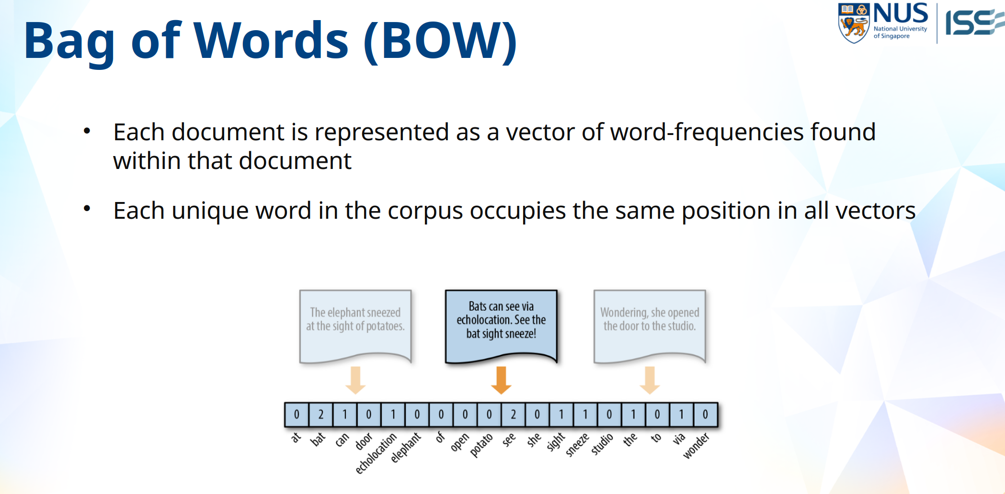
2. The feature-vector for the middle document is already provided in the slide. The Term Frequency is already provided in the start code.

3. Manually perform IDFs for the vocabulary of the corpus.

4. Write code to compute the IDFs for the vocabulary of the corpus

5. Verify that the results from Steps 3 and 4 are the same.

5. Write code to compute the TF-IDFs for the vocabulary of the corpus

